Q1:

1. From the graph of the log monthly mortgage rate and acf, the time series is not stationary.



1. The first differenced series becomes stationary as it passed the unit-root test.



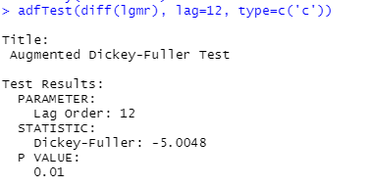

1. AR(1), MA(1) and ARMA(1,1) models were compared.



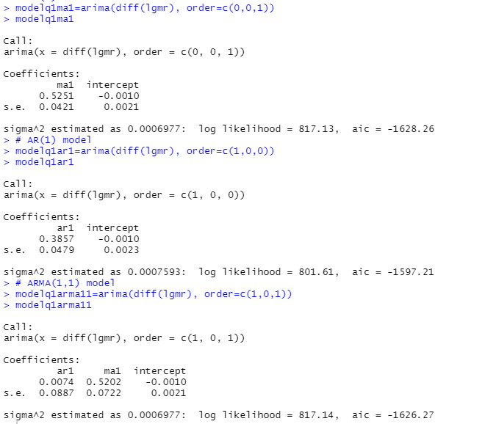

1. MA(1) model has the lowest AIC value among three and thus it was chosen for fitting with the intercept fixed as 0. From the result of Ljung-Box Test, the model is adequate. 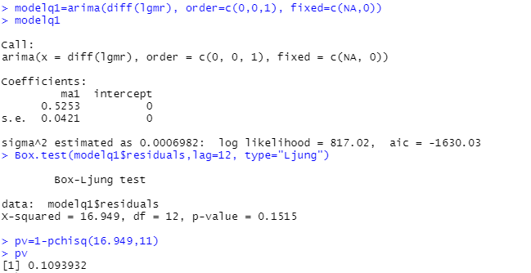
2. Let $r_{t}$ denote the monthly mortgage rate. The fitted model is:

$r_{t}-r_{t-1}=a_{t}+0.5253a_{t-1}$, which is equivalent to

$$r_{t}=r_{t-1}+a_{t}+0.5253a_{t-1}$$

1. The 1-step to 4-step ahead forecasts are given below:

|  |  |  |
| --- | --- | --- |
| Number of step ahead | Month | Forecast of $r_{t}$ |
| 1 | April 2007 | 6.091312 |
| 2 | May 2007 | 6.096261 |
| 3 | June 2007 | 6.101215 |
| 4 | July 2007 | 6.106172 |

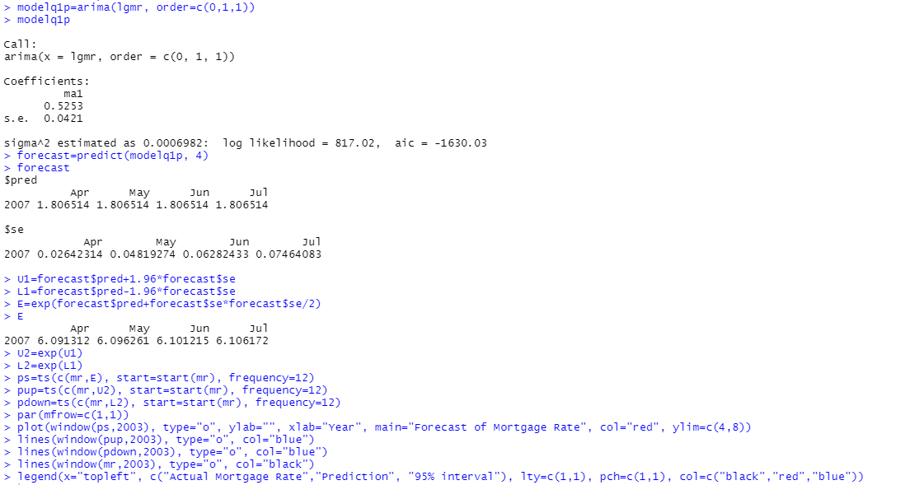



Q2:

1. The monthly simple return is fitted with ARIMA(0,0,1)(1,0,1) model as below:

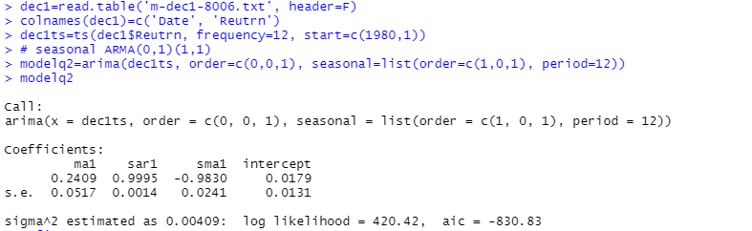

1. As the intercept is not significantly different from 0, the model is fitted again with intercept fixed to 0. AIC of the newly fitted model decreased.

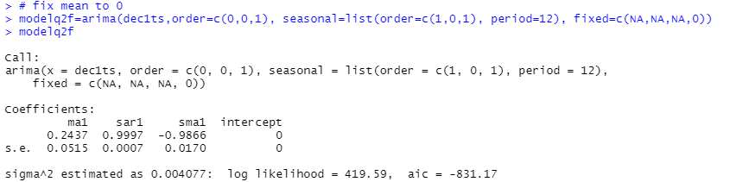

1. From the result of Ljung-Box Test with lag-24, the model is adequate.

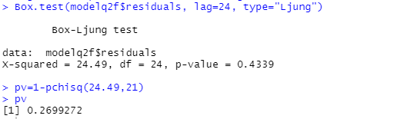

1. Let $r_{t}$ denote the monthly simple return. The form of the ARIMA(0,0,1)(1,0,1) model is:

$(1-ΦB^{12})r_{t}=({1-θB)(1-ΘB^{12})a}_{t}$

Hence, the fitted model is:

$(1-0.9997B^{12})r_{t}=({1+0.2437B)(1-0.9866B^{12})a}_{t}$, which is equivalent to

$$r_{t}=0.9997r_{t-12}+a_{t}+0.2437a_{t-1}-0.9866a_{t-12}-0.2404a_{t-13}$$

Q3:

1. From the graph of the quarterly earnings and unit root test, the time series is not stationary.



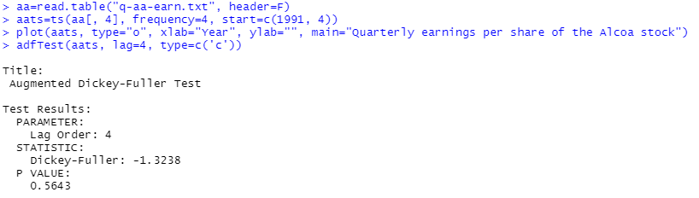

1. The first differenced series becomes stationary as it passed the unit-root test.



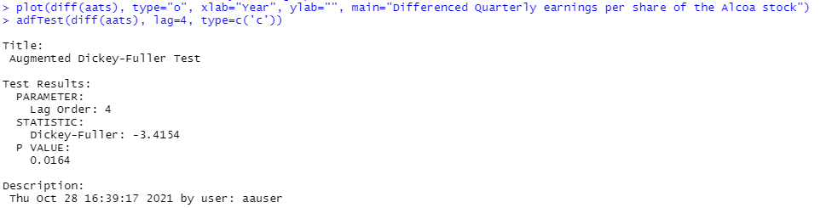

1. Looking into the ACF and PACF of the differenced time series, it is not obvious to determine which model is appropriate.
2. Different models were compared in which ARIMA(4,1,0) has the lowest AIC.

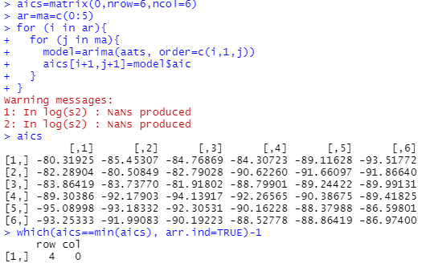

1. ARIMA(4,1,0) model was fitted and the result of Ljung-Box test shows that the model is adequate.

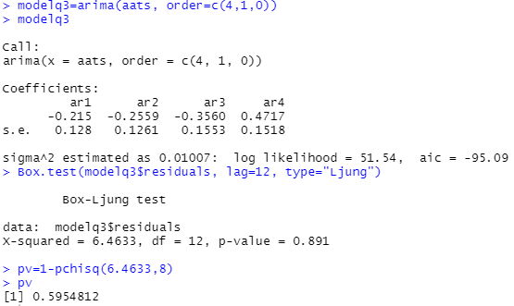

1. Let $r_{t}$ denote the quarterly earnings per share of the Alcoa stock. The fitted model is:

$(1-ϕ_{1}B-ϕ_{2}B^{2}-ϕ_{3}B^{3}-ϕ_{4}B^{4})(1-B)r_{t}=a_{t}$

$$r_{t}=\left(1+ϕ_{1}\right)r_{t-1}+\left(ϕ_{2}-ϕ_{1}\right)r_{t-2}+\left(ϕ_{3}-ϕ_{2}\right)r_{t-3}+\left(ϕ_{4}-ϕ_{3}\right)r_{t-4}-ϕ_{4}r_{t-5}+a_{t}$$

$$r_{t}=0.785r_{t-1}-0.0409r_{t-2}-0.1001r_{t-3}+0.8277r_{t-4}-0.4717r_{t-5}+a_{t}$$

1. The 1-step to 4-step ahead forecasts are given below:

|  |  |  |
| --- | --- | --- |
| Number of step ahead | Quarter | Forecast of $r_{t}$ |
| 1 | Q1 2007 | 0.5138163 |
| 2 | Q2 2007 | 0.7021985 |
| 3 | Q3 2007 | 0.8829191 |
| 4 | Q4 2007 | 0.7015811 |

